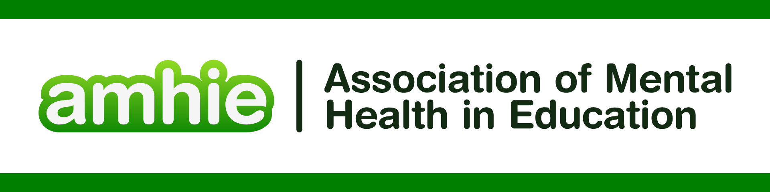

**REFERENCES FOR AI IN EDUCATION**

AI for Education. 2025 AI for Education. <https://www.aiforeducation.io/> accessed 29/8/2025

AI in Education. 2025 AI in Education. <https://www.ai-in-education.co.uk/> accessed 29/8/2025

GOV.UK. ‘AI in schools and colleges: what you need to know’ Department for Education, 10th June 2025

GOV.UK. ‘AI revolution to give teachers more time with pupils’ Department for Education, 10th June 2025

GOV.UK. ‘Generative artificial intelligence (AI) in education’ Department for Education 12th August 2025

GOV.UK. ‘Research on public attitudes towards the use of AI in education’ Department for Education 28th August 2024

GOV.UK. ‘Teachers to get more trustworthy AI tech, helping them mark homework and save time’ Department for Education 28th August 2024

GOV.UK. ‘Using AI in education: support for school and college leaders’ Department for Education 10th June 2025

Harry Alexander; (2023) Role of AI in Education, Injuruty: Interdisciplinary Journal and Humanity Volume 2, Number 3, March 2023 e-ISSN: 2963-4113 and p-ISSN: 2963-3397

Ke Zhang, Ayse Begum Aslan, AI technologies for education: Recent research & future directions, Computers and Education: Artificial Intelligence, Volume 2, 2021, 100025, ISSN 2666-920X, <https://doi.org/10.1016/j.caeai.2021.100025>.

Luckin, R; Holmes, W; (2016) Intelligence Unleashed: An argument for AI in Education. UCL Knowledge Lab: London, UK.

Nguyen, N. D. (2023). Exploring the role of AI in education. *London Journal of Social Sciences*, (6), 84–95. <https://doi.org/10.31039/ljss.2023.6.108>

Nur Fitria, Tira. (2021). Artificial Intelligence (AI) In Education: Using AI Tools for Teaching and Learning Process.

Schiff, D. Education for AI, *not* AI for Education: The Role of Education and Ethics in National AI Policy Strategies. *Int J Artif Intell Educ* **32**, 527–563 (2022). <https://doi.org/10.1007/s40593-021-00270-2>

Srinivasa, K.G., Kurni, M., Saritha, K. (2022). Harnessing the Power of AI to Education. In: Learning, Teaching, and Assessment Methods for Contemporary Learners. Springer Texts in Education. Springer, Singapore. <https://doi.org/10.1007/978-981-19-6734-4_13>

UNESCO. ‘AI and Education: Guidance for Policy Makers’ 2021

Yang, S. J. H. (2021). Guest Editorial: Precision Education - A New Challenge for AI in Education. Educational Technology & Society, 24 (1), 105–108