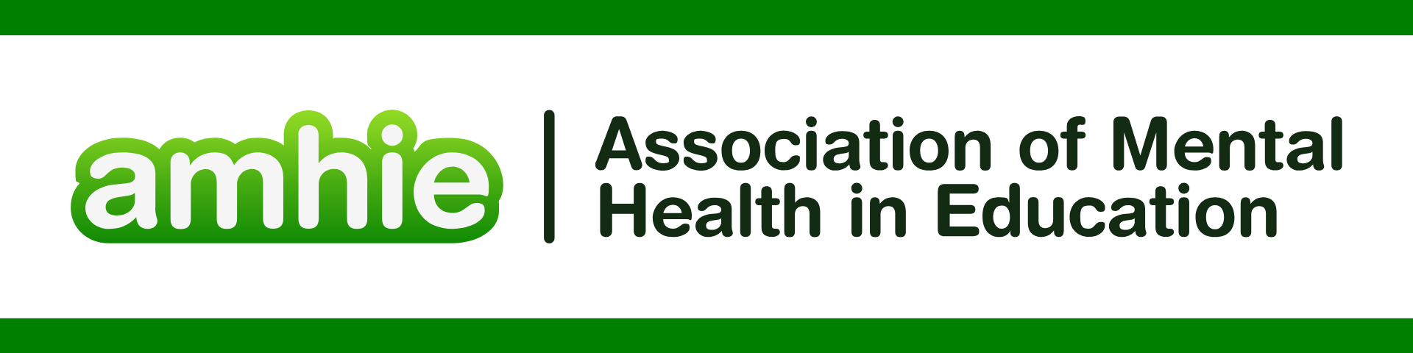

DFE & Public Health England. “Promoting children and young persons mental health in schools” <https://assets.publishing.service.gov.uk/media/614cc965d3bf7f718518029c/Promoting_children_and_young_people_s_mental_health_and_wellbeing.pdf>

**REFERENCES FOR CURRICULUM AND LEARNING**

Burgess, Hilary, Jill Anderson, and Nicola Westerby. "Promoting mental well-being in the curriculum." (2009).

De Cates, Angharad N., et al. "Can curriculum design influence medical students’ attitudes to psychiatry? A comparison of two different approaches." *Medical teacher* 41.8 (2019): 939-948.

Gorton, H. C., et al. "UK and Ireland survey of MPharm student and staff experiences of mental health curricula, with a focus on Mental Health First Aid." *Journal of Pharmaceutical Policy and Practice* 14.1 (2021): 73.

Hassoulas, Athanasios, et al. "A case-based medical curriculum for the 21st century: the use of innovative approaches in designing and developing a case on mental health." *Medical Teacher* 39.5 (2017): 505-511.

Hargreaves, Jackie, Belinda Cooke, and Jim McKenna. "Integrating Mental Health in Curriculum Design: Reflections from a Case Study in Sport, Exercise, and Health Science." *Education Sciences* 15.5 (2025): 529.

Houghton, Ann-Marie, and Jill Anderson. "Embedding mental wellbeing in the curriculum: maximising success in higher education." *Higher Education Academy* 68.1 (2017): 1-44.

Lewis, Fergus, Ian Hall, and Luca Polledri. "An innovative and collaborative teaching approach to delivering mental health capabilities in the UK Foundation Programme Curriculum 2021." *BJPsych Bulletin* 47.6 (2023): 347-351.

Mansfield, Rosie, et al. "Adaptation of a school-based mental health literacy curriculum: from Canadian to English classrooms." *Global Mental Health* 8 (2021): e39.

Masters, Hugh, et al. "Involving mental health service users and carers in curriculum development: moving beyond ‘classroom’involvement." *Journal of Psychiatric and Mental Health Nursing* 9.3 (2002): 309-316.

Mcluckie, Alan, et al. "Sustained improvements in students’ mental health literacy with use of a mental health curriculum in Canadian schools." *BMC psychiatry* 14.1 (2014): 379.

Milin, Robert, et al. "Impact of a mental health curriculum on knowledge and stigma among high school students: a randomized controlled trial." *Journal of the American Academy of Child & Adolescent Psychiatry* 55.5 (2016): 383-391.

Rutter, Paul, Denise Taylor, and Dave Branford. "Mental health curricula at schools of pharmacy in the United Kingdom and recent graduates’ readiness to practice." *American journal of pharmaceutical education* 77.7 (2013): 147.

Wimpenny, Katherine, et al. "Preparation for an uncertain world: International curriculum development for mental health occupational therapy." *World Federation of Occupational Therapists Bulletin* 72.1 (2016): 5-15.