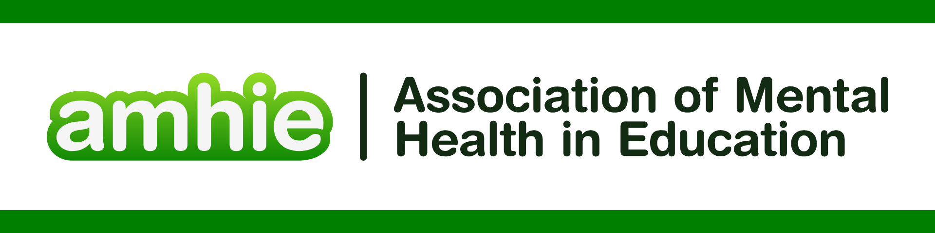

DFE & Public Health England. “Promoting children and young persons mental health in schools” <https://assets.publishing.service.gov.uk/media/614cc965d3bf7f718518029c/Promoting_children_and_young_people_s_mental_health_and_wellbeing.pdf>

REFERENCES FOR SPECIAL EDUCATIONAL NEEDS AND DISABILITIES:

Alderson, Priscilla. "How the Rights of All School Students and Teachers Are Affected by Special Educational Needs or Disability (SEND) Services: Teaching, Psychology, Policy." *London review of education* 16.2 (2018): 175-190.

Alimohamadi, Asgar, et al. "Emotional and psychological well-being in early adolescence: psychometric properties of the Stirling children’s well-being scale in a sample of Iranian adolescents." *BMC Public Health* 25.1 (2025): 1763.

Boddison, Adam, and Helen Curran. "The experience of SENCOs in England during the COVID‐19 pandemic: the amplification and exposure of pre‐existing strengths and challenges and the prioritisation of mental health and wellbeing in schools." *Journal of Research in Special Educational Needs* 22.2 (2022): 126-136.

Brown, Rebecca. "Mental health and wellbeing provision in schools." *Review of Published Policies and Information* (2018).

Dimitrellou, Eleni, and Dawn Male. "Understanding what makes a positive school experience for pupils with SEND: can their voices inform inclusive practice?." *Journal of Research in Special Educational Needs* 20.2 (2020): 87-96.

Liddle, Ian, and Greg FA Carter. "Emotional and psychological well-being in children: the development and validation of the Stirling Children’s Well-being Scale." *Educational Psychology in Practice* 31.2 (2015): 174-185.

Ng Fat, Linda, et al. "Evaluating and establishing national norms for mental wellbeing using the short Warwick–Edinburgh Mental Well-being Scale (SWEMWBS): findings from the Health Survey for England." *Quality of Life Research* 26.5 (2017): 1129-1144.

O’Reilly, Michelle, et al. "Whose responsibility is adolescent’s mental health in the UK? Perspectives of key stakeholders." *School mental health* 10.4 (2018): 450-461.

Stewart-Brown, Sarah, and Kulsum Janmohamed. "Warwick-Edinburgh mental well-being scale." *User guide. Version* 1.10.1037 (2008): 2.

Tennant, Ruth, et al. "The Warwick-Edinburgh mental well-being scale (WEMWBS): development and UK validation." *Health and Quality of life Outcomes* 5.1 (2007): 63.

Unwin, Gemma L., Biza Stenfert Kroese, and Jessica Blumson. "An evaluation of a mental health promotion programme to improve emotional, social and coping skills in children and young people attending special schools." *Frontiers in Education*. Vol. 3. Frontiers Media SA, 2018.