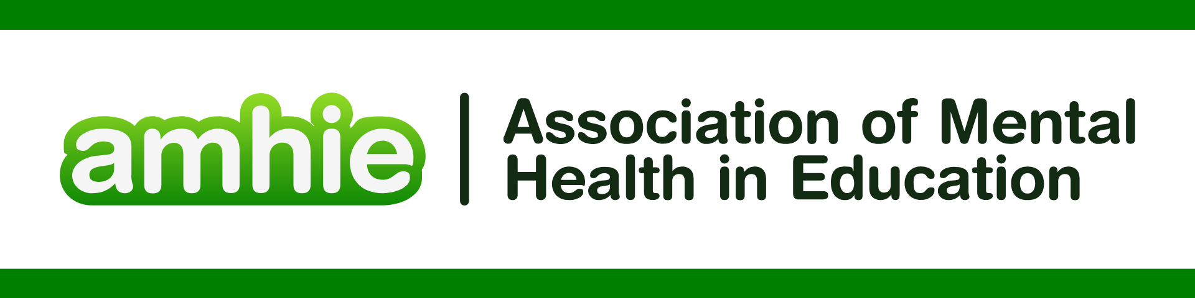

DFE & Public Health England “Promoting children and young people’s mental health and wellbeing” <https://assets.publishing.service.gov.uk/media/614cc965d3bf7f718518029c/Promoting_children_and_young_people_s_mental_health_and_wellbeing.pdf>

REFERENCES

Alkan, Vesile. "Pupils' voice:" My primary school teacher''." *Educational Research and Reviews* 8.11 (2013): 777.

Atkinson, Cathy, et al. "Developing a student-led school mental health strategy." *Pastoral Care in Education* 37.1 (2019): 3-25.

Bragg, Sara. "‘But I listen to children anyway!’—teacher perspectives on pupil voice." *Educational Action Research* 15.4 (2007): 505-518.

Demetriou, H. "More reasons to listen: Learning lessons from pupil voice for psychology and education." *International Journal of Student Voice* 5.3 (2019): 1-27.

Donaldson, Andrew. *Educational psychologists’ experiences of establishing and promoting pupil voice among children in care*. Diss. Cardiff University, 2020.

Dolton, Alice, Sarah Adams, and Michelle O’Reilly. "In the child’s voice: The experiences of primary school children with social, emotional and mental health difficulties." *Clinical child psychology and psychiatry* 25.2 (2020): 419-434.

Flynn, Paula, Michael Shevlin, and Anne Lodge. "Pupil voice and participation." (2021).

Hopkins, Elizabeth A. "Classroom conditions to secure enjoyment and achievement: the pupils' voice. Listening to the voice of Every child matters." *Education 3–13* 36.4 (2008): 393-401.

Glazzard, Jonathan, and Anthea Rose. "The impact of teacher well-being and mental health on pupil progress in primary schools." *Journal of Public Mental Health* 19.4 (2020): 349-357.

James, Emma Louise. *Pupil voice in school non attendance: exploring the perceptions of pupils, whose attendance is below 85%*. Diss. University of Birmingham, 2016.

Littlefair, David, Michael Jopling, and Nancy Kelly. "Pupil voice in physical education and the desire for (in) visibility." *Sport, Education and Society* 30.6 (2025): 728-741.

Littlefair, David, and Michael Jopling. "Pupil voice as a method in education research: thinking the ‘in-between’." *Oxford Review of Education* (2025): 1-16.

Manktelow, Christina. *An Exploration of Pupil Voice Practice in a Virtual School, Using an Appreciative Inquiry Approach*. Diss. University of East London, 2023.

Marsh, Helena. "Relationships for learning: using pupil voice to define teacher− pupil relationships that enhance pupil engagement." *Management in Education* 26.3 (2012): 161-163.

McIntyre, Donald, David Pedder\*, and Jean Rudduck. "Pupil voice: Comfortable and uncomfortable learnings for teachers." *Research papers in education* 20.2 (2005): 149-168.

Pritchard, Isobel. *Exploring Educators’ Viewpoints on Supporting their Pupils’ Mental Health: AQ methodological Study*. Diss. University of Nottingham, 2021.

Rubenstein, Eric, James D. Scott, and Jason Peake. "Pupil voice groups: The impact on schools and students." *Journal of Youth Development* 17.4 (2022): 4.

Westwood, Corrin. "“The stories we tell of other people are always going to somehow be influenced by our own story.”-exploring Educational Psychologists’ constructions of the meaning, value, and purpose of pupil voice." (2024).

Woozley, Emma. *Envisioning the ‘ideal school’ for mental health: an exploration of the mediators underpinning universal interventions, and empowering pupil voice to shape school systems*. Diss. University of Southampton, 2025.