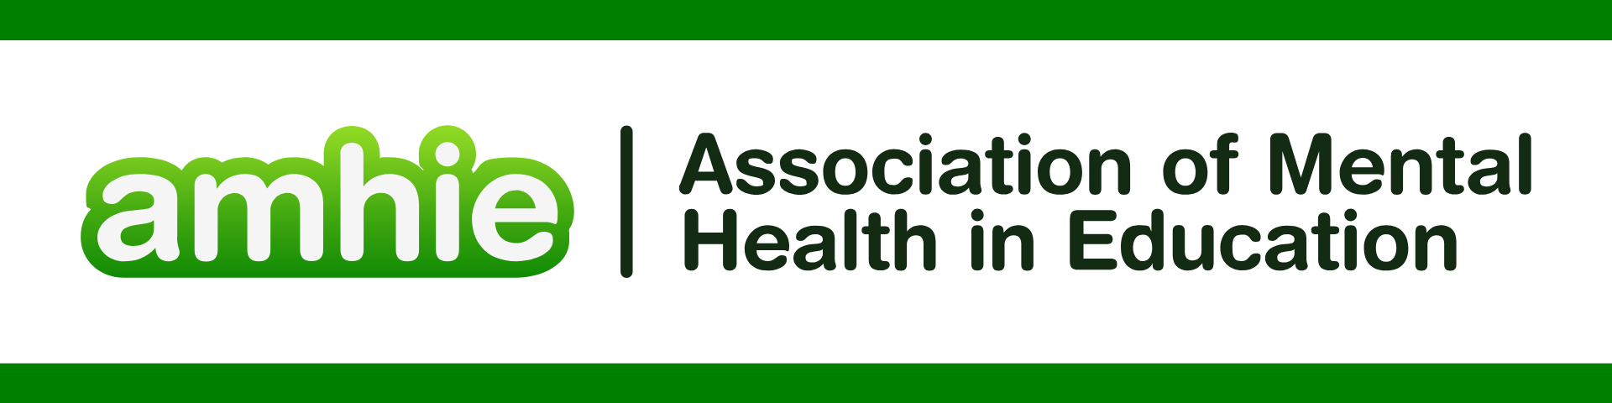

DFE & Public Health England “Promoting children and young people’s mental health and wellbeing” <https://assets.publishing.service.gov.uk/media/614cc965d3bf7f718518029c/Promoting_children_and_young_people_s_mental_health_and_wellbeing.pdf>

REFERENCES FOR TARGETED SUPPORT

Abel, Kathryn M., et al. "Enhancing referrals to Child and Adolescent Mental Health Services: the EN-CAMHS mixed-methods study." *Health and Social Care Delivery Research* 13.21 (2025).

Adindu, Kelechi Nelson, et al. "Early Detection and Intervention for Adolescent Mental Health Disorders: Evaluating the Effectiveness of School Mental Health Leads vs. Nhs Child and Adolescent Mental Health Services (Camhs)." (2025).

Brown, June SL, and Ben Carter. "School based interventions for depression and anxiety in UK." *Journal of Mental Health* (2025): 1-5.

Carroll, Catherine, and Jane Hurry. "Supporting pupils in school with social, emotional and mental health needs: a scoping review of the literature." *Emotional and Behavioural Difficulties* 23.3 (2018): 310-325.

Ellins, Jo, et al. "Implementing mental health support teams in schools and colleges." (2023).

Ellins, Jo, et al. "Implementing mental health support teams in schools and colleges: the perspectives of programme implementers and service providers." *Journal of Mental Health* 33.6 (2024): 714-720.

Garside, Megan, et al. "Mental health provision in UK secondary schools." *International journal of environmental research and public health* 18.22 (2021): 12222.

Gilmour, Lynne, et al. "Characteristics and outcomes of referrals to CAMHS for children who are thinking about or attempted suicide: A retrospective cohort study in two Scottish CAMHS." *Frontiers in psychiatry* 13 (2022): 914479.

Grant, Claire, et al. "Impact of counselling provision in primary schools on child and adolescent mental health service referral rates: a longitudinal observational cohort study." *Child and Adolescent Mental Health* 28.2 (2023): 212-220.

Haste, Anna, et al. "Embedding mental health provision within schools–Evaluation of a North East England mental health support team." *Mental Health & Prevention* 39 (2025): 200435.

Kaip, Dennis, et al. "Educator perceptions of the complex needs of young people in Pupil Referral Units: An exploratory qualitative analysis." *Plos one* 19.9 (2024): e0310633.

Mackenzie, Karen, and Christopher Williams. "Universal, school-based interventions to promote mental and emotional well-being: What is being done in the UK and does it work? A systematic review." *BMJ open* 8.9 (2018): e022560.

Robinson, Emilia, et al. "Characteristics of young people referred for treatment of depression and anxiety in a school‐based mental health service." *British Journal of Clinical Psychology* (2025).

Skene, Kayleigh. *Exploring the Current and Developing Role of Educational Psychologists within Mental Health Support Teams: A Solution-Oriented Multiple Case Study Approach*. Diss. University of East Anglia, 2023.

Smith, Joanna, et al. "Patterns of referral and waiting times for specialist Child and Adolescent Mental Health Services." *Child and Adolescent Mental Health* 23.1 (2018): 41-49.