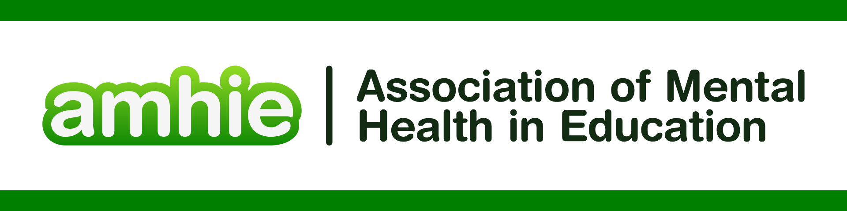

DFE & Public Health England “Promoting children and young people’s mental health and wellbeing” <https://assets.publishing.service.gov.uk/media/614cc965d3bf7f718518029c/Promoting_children_and_young_people_s_mental_health_and_wellbeing.pdf>

REFERENCES FOR WORKING WITH PARENTS, FAMILIES AND CARERS

Argent, Karen. "Every Child Matters: change for parents/carers and families? Can schools work with families to promote knowledge and understanding of government expectations?." *Education 3–13* 35.3 (2007): 295-303.

Barnes, Sally-Anne, et al. "The role of parents and carers in providing careers guidance and how they can be better supported: international evidence report." (2020).

Bartolo, Paul, and Carmel Cefai. "Parents’/carers’ participation in mental health promotion in schools." *Mental health promotion in schools: Cross-cultural narratives and perspectives*. Rotterdam: SensePublishers, 2017. 197-205.

Christie, Hope, et al. "Examining harmful impacts of the COVID‐19 pandemic and school closures on parents and carers in the United Kingdom: A rapid review." *JCPP advances* 2.3 (2022): e12095.

Gore, Helen. *" Working together... it doesn't go far enough actually for what the relationship becomes"-An IPA study exploring the experiences of primary school SENCOs working with parents/carers through the EHCP process*. Diss. University of Essex and Tavistock & Portman NHS Trust, 2016.

Hasson, Laurence, et al. "Inclusivity in education for autism spectrum disorders: Experiences of support from the perspective of parent/carers, school teaching staff and young people on the autism spectrum." *International Journal of Developmental Disabilities* 70.2 (2024): 201-212.

Holmes, Sarah E., Shelley Logan, and Emma Olorenshaw. "Working towards improved collaboration: reviewing provision and support for Christian parents/carers." *British Journal of Religious Education* 47.3 (2025): 335-349.

Jones, Chris. "Don’t forget the parents: Preparing trainee teachers for family–school partnership." *Practice* 2.1 (2020): 68-85.

Kakoulidou, Myrofora, et al. "Involving children, teachers and parents/carers in dialogues around child well-being in schools." *Research for All* 7.1 (2023).

Mutton, Trevor, Katharine Burn, and Ian Thompson. "Preparation for family-school partnerships within initial teacher education programmes in England." *Journal of Education for Teaching* 44.3 (2018): 278-295.

Salamon, Eszter. "Parents: Primary educators, caregivers, gatekeepers, scaffolders." *Parents International* (2019).

Rickett, Bridgette, et al. "Support for parents/carers of primary school aged gender diverse children in England, UK: A mixed-method analysis of experiences with health services." *Social Perspectives on Trans Health*. Routledge, 2024. 9-24.

Rose, Janet, et al. "Attachment aware schools: working with families to enhance parental engagement and home-school relationships." *The Open Family Studies Journal* 9.1 (2023): 160-171.

Wallis, Fiona. *In what ways do the views of parents/carers change through the participation in Multi-Family Groups in Schools?*. Diss. University of East London, 2023.

Warhurst, Amy, Sarah Bayless, and Emma Maynard. "Teachers’ perceptions of supporting young carers in schools: identifying support needs and the importance of home–school relationships." *International Journal of Environmental Research and Public Health* 19.17 (2022): 10755.